HONG KONG INSTITUTE OF VOCATIONAL EDUCATION
Laboratory 6b: Database Connection

TASK:

1. Write a python program to create a database named “student_module_db”
Answer:

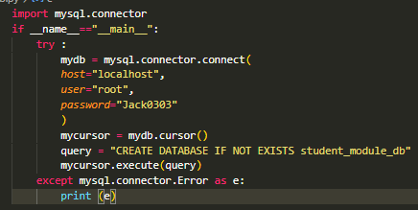

2. Complete the method create_table to create three tables by using the following SQL statements:

CREATE TABLE IF NOT EXISTS student (
id VARCHAR(9) NOT NULL,
name VARCHAR(100),
PRIMARY KEY (id)
)

CREATE TABLE IF NOT EXISTS module (
id VARCHAR(7) NOT NULL,
name VARCHAR(100),
PRIMARY KEY (id)
)

CREATE TABLE IF NOT EXISTS registration (
student_id VARCHAR(9),
module_id VARCHAR(7),
PRIMARY KEY (student_id, module_id),
FOREIGN KEY (student_id) REFERENCES student(id),
FOREIGN KEY (module_id) REFERENCES module(id)
)

import mysql.connector
class ConnectDB:
try :
mydb = mysql.connector.connect(
host="localhost",
user="root",
password="",
database="student_module_db"
)
except mysql.connector.Error as e:
print (e)

def create_table():
try :
# Complete the following codes
# to create 3 tables

except mysql.connector.Error as e:
print (e)

if __name__=="__main__":
ConnectDB.create_table()

Answer:

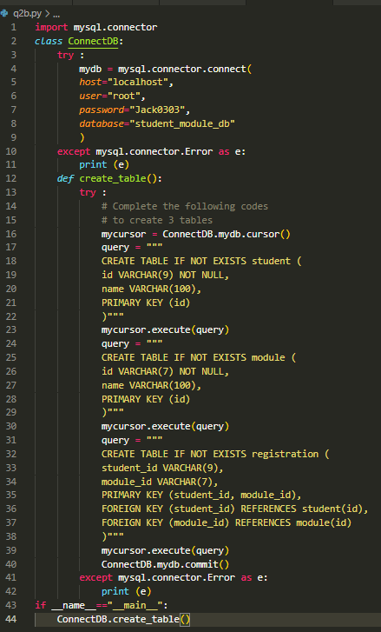

3. With the following sample code given, write the students and modules in tuples into corresponding tables in database.

import mysql.connector
class ConnectDB:
try :
mydb = mysql.connector.connect(
host="localhost",
user="root",
password="",
database="student_module_db"
)
def insert_students(students):
# Complete your codes in this method here

def insert_modules(modules):
# Complete your codes in this method here

def insert_registrations(registrations):
# Complete your codes in this method here

except mysql.connector.Error as e:
print (e)

if __name__=="__main__":
# You are NOT allowed to modify the following codes
students = (("201234567","Kelvin"),("202345678", "Peter"))
modules = (("ITE3102", "Network Fundamentals"),
("ITP3915", "Programming Fundamentals"),
("ITP4456", "Database Applications"),
("ITP4451", "IoT Fundamentals"),
("ITP4457", "Web Technologies"),
("ITP4458", "Wireless Technologies"),
("ITP4459", "Advanced Scripting Technology"),
("ITP4410", "Internet Programming"),
("ITP4413", "Server Administration"))
registrations = (("201234567", "ITE3102"),
("201234567", "ITP3915"),
("201234567", "ITP4456"),
("201234567", "ITP4451"),
("201234567", "ITP4457"),
("201234567", "ITP4458"),
("201234567", "ITP4459"),
("202345678", "ITE3102"),
("202345678", "ITP3915"),
("202345678", "ITP4456"),
("202345678", "ITP4459"),
("202345678", "ITP4410"),
("202345678", "ITP4413"))
ConnectDB.insert_students(students)
ConnectDB.insert_modules(modules)
ConnectDB.insert_registrations(registrations)

Answer:

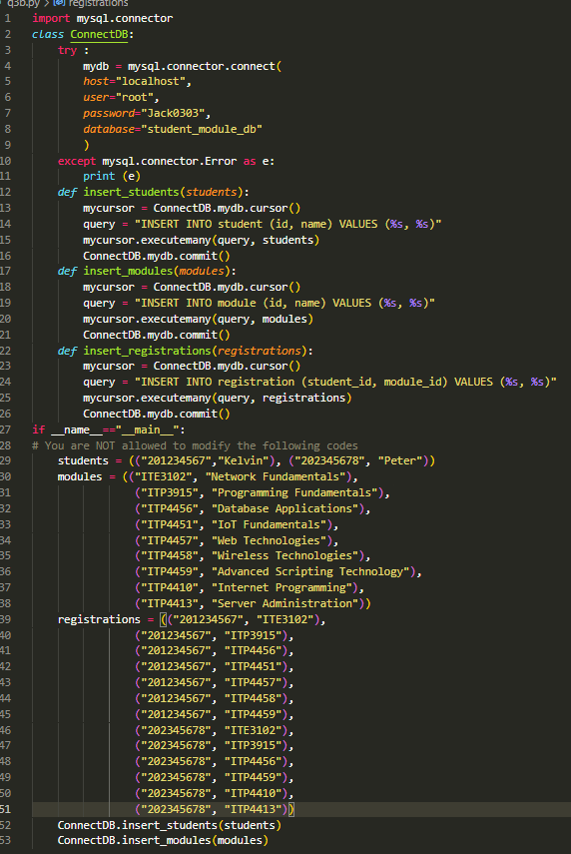

4. Complete the read_student_from_db method in ConnectDB class to read students and their corresponding modules from database. You are NOT required to modify any code in Student class, Module class or client program.

import mysql.connector
class Student :
def __init__(self, id, name):
self.__id = id
self.__name = name
self.__list_module = list()
def add_module(self, module):
self.__list_module.append(module)
def display(self):
print (f"Student {self.__name} ({self.__id}) "
f"enrolled the following module(s):")
for module in self.__list_module:
print (module)
class Module:
def __init__(self, id, name):
self.__id = id
self.__name = name
def __str__(self):
return f"\t{self.__id} - {self.__name}"
def __eq__(self, other):
if self.__id == other.__id:
return True

class ConnectDB:
try :
mydb = mysql.connector.connect(
host="localhost",
user="root",
password="",
database="student_module_db"
)
except mysql.connector.Error as e:
print (e)

def read_student_from_db():
# Complete this method

if __name__=="__main__":
print("Students in database:")
list_student = ConnectDB.read_student_from_db()
# display stduent information
for student in list_student:
student.display()

Output:
Student Kelvin (201234567) enrolled the following module(s):
ITE3102 - Network Fundamentals
ITP3915 - Programming Fundamentals
ITP4456 - Database Applications
ITP4451 - IoT Fundamentals
ITP4457 - Web Technologies
ITP4458 - Wireless Technologies
ITP4459 - Advanced Scripting Technology
Student Peter (202345678) enrolled the following module(s):
ITE3102 - Network Fundamentals
ITP3915 - Programming Fundamentals
ITP4456 - Database Applications
ITP4459 - Advanced Scripting Technology
ITP4410 - Internet Programming
ITP4413 - Server Administration
Answers: